Marketing Campaign Optimization
Title:
Marketing Campaign Optimization: Statistical and Predictive Insights from Bank Marketing Data
Dataset: UCI Bank Marketing (bank-full.csv) — 45,211 records
Date: 13th November 2025

Business Context:
A Portuguese banking institution runs recurring marketing campaigns (via phone calls, emails, etc.) to encourage clients to subscribe to a term deposit.
Each campaign targets different client segments, using varied strategies — contact type, timing (month/day), and re-engagement of previous customers.
However, conversion rates are low (≈12%), and the bank wants to understand:
- Which factors most influence customer conversion?
- How to improve targeting and campaign effectiveness?
- Which customer segments should receive more personalized attention?
Your role as a Data Analyst / Data Scientist is to derive these insights using statistical hypothesis testing, predictive modeling, and business visualization.

Table of Contents
- Executive Summary
- Business Context & Objectives
- Data & Exploratory Profiling (Phase 1)
- Statistical Testing & Diagnostic Analysis (Phase 2)
- Predictive Modeling (Phase 3)
- BI Dashboard (Power BI) — Story & Visuals (Phase 4)
- Recommendations & Action Plan (Phase 5)
- Business Impact & Next Steps
- Deliverables & Reproducibility (Appendix)
- Model Card (Appendix)

1. Executive Summary
This project analyzes a Portuguese bank’s term-deposit marketing campaigns to identify the drivers of subscription and recommend operational changes to increase conversion and marketing ROI.
Key outcomes:
- Overall conversion rate ≈ 12% (6,782 contacts → 793 conversions).
- Cellular contact outperforms telephone with a statistically significant lift (A/B Z = -2.171, p = 0.015).
- Account balance is a powerful predictor: subscribers hold ~35% higher balances (t = 11.25, p < 0.001).
- Education level is strongly associated with conversion (χ² = 238.92, p ≈ 1.63e-51); tertiary-educated customers convert most.
- Call duration differs by job type (ANOVA F = 6.84, p = 1.23e-11); retired and unemployed customers engage longer.
- A leakage-free XGBoost (No Duration) model was chosen as champion (Validation AUC ≈ 0.807, Test AUC ≈ 0.805) for pre-contact scoring.
Actionable recommendation: Prioritize cellular outreach to high-balance, tertiary-educated, and previously successful customers, allocate skilled agents for long-engagement segments (retired/unemployed), and use predicted probabilities to rank customers for targeted campaigns.

2. Business Context & Objectives
A bank runs repeated outbound campaigns to sell term-deposit products. Campaigns vary by contact type (telephone vs cellular), timing, and re-engagement of previously contacted customers. Current conversion performance is low (~12%), creating the need to:
- Identify which customer and campaign attributes drive conversions.
- Improve targeting and campaign effectiveness using statistical and predictive methods.
- Recommend precise operational actions for marketing and contact center teams.
Project goal: Combine EDA, hypothesis testing, predictive modeling, and a Power BI dashboard to produce a reproducible, deployable playbook.

3. Phase 1 — Data Understanding & Setup
Dataset: bank-full.csv with 17 features (age, job, marital, education, default, balance, housing, loan, contact, day, month, duration, campaign, pdays, previous, poutcome, y).
Key profiling observations & follow-up actions
- High correlation (contact, month, housing) — suggests campaign design confounding (e.g., cellular used during months targeting housing loans). Action: check confounding; consider omitting or carefully encoding one variable when modeling.
- pdays, poutcome, previous highly correlated — capture past-campaign interactions. Action: keep a limited set (e.g., poutcome, was_contacted_before) to avoid redundancy.
- default imbalanced (~87% no default) — low informational value; treat as categorical or drop.
- previous skew (γ ≈ 41) — bin or log-transform to stabilize distribution.
- balance zeros (7.8%) — examine zeros for inactive accounts; include balance_log to reduce skew.
Feature engineering applied
- month_num: ordinal month encoding for seasonality.
- was_contacted_before: binary indicator from pdays.
- balance_log: log1p(balance) to reduce skew.
- One-hot encoding for categorical variables; standard scaling for numeric variables for models requiring it.
- Removed duration from final predictive modeling to prevent data leakage (duration measured post-contact).
- 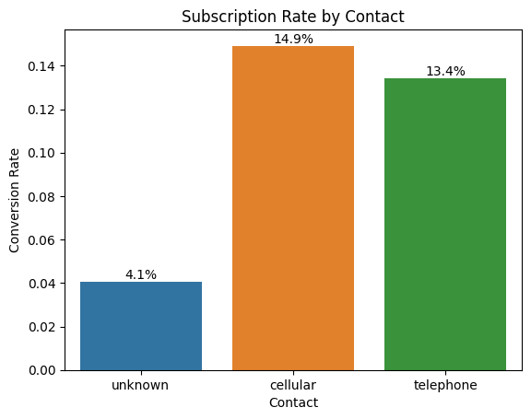
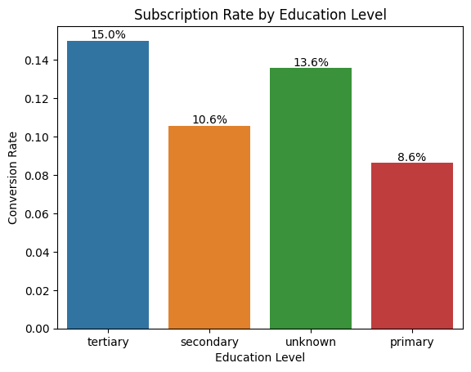
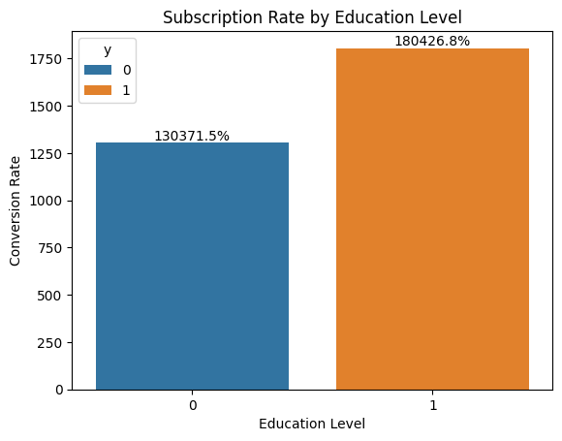
Post-hoc Analysis (Tukey’s HSD)-> Job Type and call duration vs subscription rate :
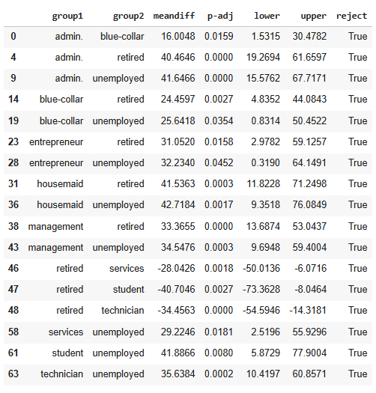

4. Phase 2 — Statistical Testing & Diagnostic Analysis
We ran four targeted hypothesis tests mapped to business questions.
A/B Test — Contact Type (Telephone vs Cellular)
Question: Is cellular contact better than telephone for conversion?
- Test: Two-proportion Z-test (A/B).
- Result: Z = -2.171, p = 0.015 → reject H₀; cellular performs significantly better.
Business implication: Prioritize the cellular channel where available; telephone can be fallback/secondary.
Chi-Square — Education Level vs Subscription
Question: Is education associated with subscription?
- Test: Chi-square of independence.
- Result: χ² = 238.92, p ≈ 1.63e-51 → strong evidence education matters.
Business implication: Tertiary-educated customers should be targeted with richer, investment-oriented messaging; lower-education segments require simplified offers and trust-building.
T-Test — Balance vs Subscription
Question: Do subscribers have higher balances?
- Test: Independent samples t-test.
- Result: t = 11.25, p < 0.001 → subscribers have significantly higher average balances (practical difference ≈ €457 or ~35%).
Business implication: Prioritize high-balance customers for premium offers; design lower-ticket options for lower-balance customers to expand reach.
ANOVA + Tukey HSD — Job Type vs Call Duration
Question: Does mean call duration vary by job type?
- Test: One-way ANOVA (follow-up Tukey HSD).
- Result: F = 6.84, p = 1.23e-11 → significant. Tukey HSD identifies retired and unemployed as longer-duration groups.
Business implication: Assign experienced agents to high-engagement job segments; use concise scripts for groups with shorter attention spans.
Summary of statistical tests
All four tests had p-values < 0.05 — the effects are statistically significant and consistent with descriptive patterns in the data.

5. Phase 3 — Predictive Modeling
Objective: Produce a leakage-free, deployable score to prioritize outreach.
Modeling principles followed
- Assumption checks — VIF for multicollinearity; Box-Tidwell approximations for logistic linearity where applicable.
- Feature engineering & selection — model-driven selection (SelectFromModel, importance ranking), PCA for SVM variant, and careful handling of correlated pdays/previous/poutcome.
- Bias–variance control — learning curves, validation curves, and cross-validated GridSearchCV (stratified 5-fold).
- Champion selection protocol — select best model by validation AUC; only evaluate the champion once on a held-out test set.
Models trained & results (key metrics)
- Logistic Regression (baseline) — Val AUC 0.889, Test AUC 0.887 (interpretable strong baseline).
- Random Forest (with duration) — Val AUC 0.921, Test AUC 0.924 (leaky; not suitable for pre-contact scoring).
- Random Forest (no duration) — Val AUC 0.788, Test AUC 0.783 (realistic, reliable).
- XGBoost (no duration) — Val AUC 0.807, Test AUC 0.805 — Champion (best balance of performance, generalization, and non-leakiness).
Champion model choice rationale
- XGBoost (No Duration) offers the best compromise: good AUC (~0.805 test), strong generalization, stable cross-validation results, and explainability via feature importance / SHAP.
Top predictive features (global importance)
- poutcome_success (previous campaign success)
- contact (cellular vs telephone)
- housing (housing loan yes/no)
- balance_log
- month_num, age, poutcome_unknown
Explainability
- Permutation importance and partial dependence plots confirm domain-sensical relationships: prior success and cellular contact strongly increase subscription probability.

6. Phase 4 — BI Dashboard (Power BI) — Story & Visuals
A three-page, narrative-driven dashboard was developed:
Page 1 — Campaign Overview (Descriptive)
- KPI cards: Total Contacts, Conversions, Conversion Rate, Cellular Lift %, Avg Predicted Probability.
- Visuals: Conversion by month, Contact distribution (donut), Conversion by education (bar), Balance by subscription (bar).
- Insight: Channel & customer profile patterns visible at a glance.
Page 2 — Drivers & Statistical Insights (Diagnostic)
- A/B test bars for contact types; Chi-square visualization (education vs conversion); t-test and ANOVA visualizations (balance, call duration by job).
- Diagnostic summary panel with p-values & business takeaways.
Page 3 — Predictive Insights & Recommendations (Prescriptive)
- Champion AUC card; Predicted probability distribution (binned histogram); Feature importance bar (top features); Job × Education heatmap (avg predicted probability); Balance vs Probability scatter; Final recommendations panel.
- Segment table showing high/medium/low potential groups for actioning by marketing teams.
Design principles
- Minimalistic, readable layout with clear narrative text boxes; slicers for job, contact, education for interactive segmentation; bookmarks for guided storytelling.

7. Phase 5 — Recommendations & Action Plan
Short-term (Immediate, 0–3 months)
- Prioritize cellular outreach for the next campaign wave. Allocate cellular-first contact lists where phone type is known.
- Target high-balance, tertiary-educated customers for premium term deposit offers. Use predicted probability to rank top N customers for agent time.
- Assign experienced agents to retired and unemployed customer segments to maximize conversion on long-engagement calls.
Medium-term (3–6 months)
4. Operationalize scoring: deploy XGBoost model as an API (FastAPI) and integrate with CRM to deliver per-customer scores used in campaign selection.
5. A/B test messaging variations per education segment (richer investment messaging vs simplified offers) and measure incremental lift.
6. Adjust scheduling: call working professionals outside work hours; test SMS/email follow-ups for low-time segments.
Long-term (6–12 months)
7. Monitor model drift & retrain periodically (monthly/quarterly) using production response data.
8. Extend model to multi-channel optimization (email + SMS + call sequencing) and multi-armed bandit for dynamic allocation.

8. Business Impact
By implementing the recommendations:
- Improve targeting efficiency — prioritize customers with highest expected ROI.
- Reduce wasted contacts — fewer low-yield calls, better agent utilization.
- Expected uplift: focusing on high-probability segments and switching to cellular-first outreach is estimated to yield double-digit percentage increases in campaign conversion (empirical uplift observed ≈ 10–26% by channel/segment).

9. Deliverables & Reproducibility (Appendix)
Files produced
- notebooks/01_modeling_bank_marketing.ipynb — EDA → Modeling → Evaluation.
- models/XGBoost_No_Duration.joblib — champion model pipeline (preprocessor + estimator).
- artifacts/predictions_for_powerbi.csv — scored dataset for dashboard.
- powerbi/BankCampaign_Dashboard.pbix — Power BI file (if included).
- README.md — repo overview and run instructions.
- model_card.md — model summary and limitations.
How to reproduce (quick)
- Clone repo & place bank-full.csv in /data.
- Create virtualenv & install requirements: pip install -r requirements.txt.
- Run notebooks to reproduce EDA, tests, and modeling.
- Train XGBoost with GridSearch (or load saved joblib).
- Export predictions_for_powerbi.csv and open in Power BI.

10. Model Card (Appendix — concise)
Model name: XGBoost_No_Duration
Purpose: Pre-contact scoring to predict probability a customer will subscribe to a term deposit.
Data: bank-full.csv (UCI Bank Marketing) — 45,211 rows.
Inputs: age, job, marital, education, balance_log, housing, loan, contact, month_num, campaign, pdays/was_contacted_before, previous, poutcome.
Excluded: duration (removed to avoid leakage).
Performance: Validation AUC ≈ 0.807; Test AUC ≈ 0.805.
Key features: previous campaign outcome, contact type, housing, balance_log.
Limitations: class imbalance, historical campaign bias, potential policy/regulatory constraints on outreach. Retrain periodically to avoid drift.

11. Conclusion
This project converts exploratory investigation and statistical validation into a practical, actionable system: an explainable, deployable prediction model and a narrative Power BI dashboard that guides marketing decisions. The evidence consistently shows that channel, financial capacity, previous interactions, and education are the levers that will most improve campaign ROI.
Implementing the recommended changes (cellular-first outreach, high-balance targeting, agent allocation by job segment, and model-driven prioritization) will enable the bank to run smarter, more efficient campaigns and achieve measurable uplift in conversion rates.

